

**EVALUATION OF INTERNSHIP REPORT**

## B.Tech: III Year

**Department of Computer Science & Information Technology**

**Name of the Student ……Ishika Joshi………………**

**Branch & section ………CSIT-2……...………….**

**Roll No…………0827CI201079…………………**

**Year………………2022………………...……...........**

## Department of Computer Science & Information Technology

**AITR, Indore,**

**ACROPOLIS INSTITUTE OF TECHNOLOGY & RESEARCH, INDORE**

# Department of Computer Science & Information Technology

**Certificate**

Certified that training work entitled “*RPA- Robotic Process Automation*” is a bonafied work carried out after sixth semester by “*Ishika Joshi*” in partial fulfilment for the award of the degree of Bachelor of Technology in Computer Science and Information Technology from “*Simarjit Singh Bhatia, Assistant Professor*” Acropolis Institute of Technology and Research during the academic year 2022-23.

*Name and Sign of Training Coordinator Name & Sign of Internship Coordinator*

**ACROPOLIS INSTITUTE OF TECHNOLOGY & RESEARCH, INDORE**

# Department of Computer Science & Information Technology

**ACKNOWLEDGEMENT**

I would like to acknowledge the contributions of the following people without whose help and guidance this report would not have been completed. With respect and gratitude, I acknowledge the counsel and support of our training coordinator, Simarjit Singh Bhatia, Assistant Professor, CSIT Department, whose expertise, guidance, support, encouragement, and enthusiasm have made this report possible. Their feedback vastly improved the quality of this report and provided an enthralling experience. I am indeed proud and fortunate to be supported by him/her. I am also thankful to Dr. Shilpa Bhalerao, H.O.D of the Computer Science Information Technology Department, for her constant encouragement, valuable suggestions, moral support, and blessings. Although it is not possible to name them individually, I shall ever remain indebted to the faculty members of the CSIT Department, for their persistent support and cooperation extended during this work.

*Ishika Joshi*

*0827CI201079*

### ACROPOLIS INSTITUTE OF TECHNOLOGY & RESEARCH, INDORE

### INDEX

S.no CONTENTS Page no

1. Introduction to technology Undertaken…….... 1

2. Objectives ………..……………………………….... 3

3. Project undertaken ……………………….. 4

4. Screenshots of Project and Certificates……………………….. 11

5. Github Links (Project/certificate/video/copy of report.… ……. 12

7. Conclusion……….. ……………………………………. 16

8. References/ Bibliography………………………………..…………… 17

# Introduction to Technology Undertaken

# Robotic process automation (RPA) is a software technology that makes it easy to build, deploy, and manage robots that emulate human actions interacting with digital systems and software. Just like people, software robots can do things like understand what’s on a screen, complete the right keystrokes, navigate systems, identify and extract data, and perform a wide range of defined actions. But software robots can do it faster and more consistently than people, without the need to get up and stretch or take a coffee break.

# RPA is defined as the art of using software robots to interact with Software-as-a-Service applications and IT systems to automate the rule-based manual jobs associated with repetitive and transactional processes. The robot mimics the interactions of an employee with a system's user interface. The RPA services provide data security, enhanced business efficiency, and effectiveness across various business applications without modifying available systems and infrastructure. Robotic Process Automation can be termed as the breed of technology in the industries like Machine Learning, Automation Engineering, and Artificial Intelligence. It can be considered as the low-risk process of performing business tasks in an automated manner than using the most valuable human resources on tasks that are repeated over time. Further, RPA is for non-technical businesspersons who are looking for technology that does things for them rather than doing them by themselves.

# Automation has changed the aspects of business today. In addition, the opportunity of applying robotic automation in business processes has been gaining more attention as they challenge a digital world, which requires faultless operations. With RPA Robotic Process Automation solution, businesses are automating knowledge-based, professional service processes that don't demand human interaction. Concurrently, it is serving as a fundamental activist to the conventional insight of labor arbitrage.

# When it comes to robotics and automation, people usually think of them as robots or devices. However, RPA stands for virtual or invisible robots, which sit inside the systems, moving between various applications, checking, inputting, updating, and processing more promptly that a human could. Therefore, RPA robotics is different from other direct types of automation. Like human users, RA interacts with different systems at the level of GUI or presentation layer. Hence, existing software systems can function together more efficiently; since RA completes some tasks far faster and more reliably than humans do. This logical software tool shifts manual effort away from repetitive processing functions towards optimizing business processes. A major benefit is it connects existing systems without re-engineering them. Alternately, it functions with various user interfaces like MS office documents, ERP systems, and databases. Today's RPA systems are more flexible and accurate than humans are - they enhance compliance and are available 24/7.

# RPA Features

# Rich analytical suite - RPA monitors and manages automated functions from a central console. This console can be accessed from anywhere and offers basic metrics on robots, servers, workflows, and more.

# Simple creation of bots - RPA tools enable the quick creation of bots by capturing mouse clicks and keystrokes with built-in screen recorder components.

# Scriptless automation - RPA tools are code-free and can automate any application in any department. Users with fewer programming skills can create bots through an intuitive GUI.

# Security - RPA tools enable the configuration and customization of encryption capabilities to secure certain data types to defend against the interruption of network communication.

# Hosting and deployment - RPA systems can automatically deploy bots in groups of hundreds. Hence, RPA bots can be installed on desktops and deployed on servers to access data for repetitive tasks.

# Debugging - Some RPA tools need to stop running to rectify the errors while other tools allow dynamic interaction while debugging. This is one of the most powerful features of RPA.

##### **Robotic Process Automation Tools**

RPA can be implemented with the support of various vendors. Some prominent players in the RPA market are:

Uipath, Automation Anywhere, WorkFusion, Pegasystems, Softomotive, EdgeVerve, Kofax, HelpSystems, AntWorks, NICE, Blue prism, Datamatics, Jacada, BlackLine

**RPA Services/ Processes suitable for RPA adoption**

All the usual repetitive, frequent, mundane, and high-volume tasks can benefit from RPA. As it is easy and quick to make an alteration, RPA is suited to tasks regularly adopt and change particularly those that are complex and costly to re-engineer existing systems within the short term.

Robotic process automation helps automate strenuous and monotonous jobs. Here are 11 services offered by RPA:

* Open mail and attachments
* Fill in forms and move files and folders
* Follow if-then decision rules
* Connect to system APIs
* Extract structured data from documents
* Make complex calculations
* Monitor manual processes and learn how to perform them
* Copy and paste
* Read and write to databases
* Scrape data from documents
* Login into web/enterprise applications
* High volume of repetitive computer-based processes
* Process documentation available in detail, rule-based transaction
* Low level of exception processing
* Repetitive mouse and keyboard tasks, multiple sources of data input extraction and re-formatting
* Manual data entry between multiple non-integrated systems
* An operating environment that is impossible to change

For those considering RPA initiatives, it is vital to make sure that the initiative is a business-driven instead of technology-driven. Therefore, they should determine the right processes, which can leverage optimization and cost savings opportunities. The following section will assist to sort out the processes for adoption and to get real value from RPA.

# What are the business benefits of RPA?

# Robotic process automation streamlines workflows, which makes organizations more profitable, flexible, and responsive. It also increases employee satisfaction, engagement, and productivity by removing mundane tasks from their workdays.

# RPA is noninvasive and can be rapidly implemented to accelerate digital transformation. And it’s ideal for automating workflows that involve legacy systems that lack APIs, virtual desktop infrastructures (VDIs), or database access.

**Accelerated transformation**

Among global executives, 63% say RPA is a major component in digital transformation.

[Pegasystems survey](https://www.pega.com/system/files/resources/2020-01/rpa-and-digital-transformation-report.pdf)

**Major cost savings**

RPA drives rapid, significant improvement to business metrics across industries and around the world.

[IT Central Station: Key Drivers of Time to Value in RPA](https://www.uipath.com/resources/automation-whitepapers/it-central-station-time-to-value-rpa)

**Greater resilience**

RPA robots can ramp up quickly to match workload peaks and respond to big demand spikes.

[Learn how RPA helped scale COVID testing](https://www.uipath.com/resources/automation-case-studies)

**Higher accuracy**

57% say RPA reduces manual errors.

[Forrester, "Impact of RPA on Employee Experience"](https://www.uipath.com/resources/automation-analyst-reports/forrester-employee-experience-rpa)

**Improved compliance**

92% agree RPA has ‘met or exceeded expectations’ for better compliance.

[Deloitte "3rd Annual RPA Survey" 2018](https://www2.deloitte.com/bg/en/pages/technology/articles/deloitte-global-rpa-survey-2018.html)

**Boosted productivity**

68% of global workers believe automation will make them more productive.

[UiPath survey of 4,500 global workers](https://www.uipath.com/blog/digital-transformation/new-research-shows-workers-concerned-skills-gaps)

**More value from personnel**

60% of executives agree RPA enables people to focus on more strategic work.

[Forrester, "Impact of RPA on Employee Experience"](https://www.uipath.com/resources/automation-analyst-reports/forrester-employee-experience-rpa)

**Happier employees**

57% of executives say RPA increases employee engagement.

[Forrester, "Impact of RPA on Employee Experience"](https://www.uipath.com/resources/automation-analyst-reports/forrester-employee-experience-rpa)

**In simpler words RPA:**

**Reduces cost -** One of the important advantages of RPA is the quick reduction in the cost. By automating tasks, an organization can save up to 30 percent of their total costs because software robots also cost less than a full-time employee.

**Reduces operational risks -** Some companies prefer to outsource busy work to third party organizations, and this comes with the risk of human errors and inefficiency. RPA offers a better solution—because the work stays in-house, there is less operational risk.

**Quality and accuracy -** Processes with a high risk of human error can be automated using RPA systems. These bots are reliable, consistent, and can work tirelessly.

**Scalability -** With the help of RPA, companies can make adjustments based on other crucial factors and can easily scale up or down operations as needed.

**Reduced workload -** Automating tasks like report-making can significantly reduce the workload on employees, allowing them to focus on other critical tasks.

**Improved customer satisfaction -** Since accuracy is maintained and operational risk is minimal, customers are provided with quality content.

**Improved business results -** Since employees are focusing on activities that add more value to the company, robotic process automation improves results that can be automated.

# Objectives

**RPA Services/ Processes suitable for RPA adoption**

All the usual repetitive, frequent, mundane, and high-volume tasks can benefit from RPA. As it is easy and quick to make an alteration, RPA is suited to tasks regularly adopt and change particularly those that are complex and costly to re-engineer existing systems within the short term.

Robotic process automation helps automate strenuous and monotonous jobs. Here are 11 services offered by RPA:

* Open mail and attachments
* Fill in forms and move files and folders
* Follow if-then decision rules
* Connect to system APIs
* Extract structured data from documents
* Make complex calculations
* Monitor manual processes and learn how to perform them
* Copy and paste
* Read and write to databases
* Scrape data from documents
* Login into web/enterprise applications
* High volume of repetitive computer-based processes
* Process documentation available in detail, rule-based transaction
* Low level of exception processing
* Repetitive mouse and keyboard tasks, multiple sources of data input extraction and re-formatting
* Manual data entry between multiple non-integrated systems
* An operating environment that is impossible to change

# Project Undertaken

# Introduction

# DSA-Practice-Bot has been created using RPA (Robotic Process Automation).

# Main function of this Bot is to extract the links of Data Structures and Algorithms according to the topic in the separate excel sheets. The bot will specifically provide the link of the topic which will open the webpage of the question list and you wish to practice and also email the excel sheets you wish to share it to.

# Taking an example, The bot will automatically take you to the website, <https://www.geeksforgeeks.org/> and scrap the entire topics of Data structure and algorithms along with their links and also email it to the one you wish to share it with.

# Working

# STEP-1 🡪 The Bot will take you to the website <https://www.geeksforgeeks.org/>

# STEP-2 🡪 Moving to the More data structure and algorithms section, it will extract, and scrap the entire data having the topics of various data structures and various algorithms with their links having the entire question bank of the topic.

# STEP-3 🡪 After extracting the data from the webpage it will store the extracted data in separate excel sheets having Data structure and algorithms.

# STEP-4 🡪 After storing the data in excel sheet it will ask you to email it to the person you wish to share it to. And the Bot will automatically mail those excel sheets to the person you wish to share it to.

# *This Bot is specifically for the Institutions that can provide a roadmap or the list of Data Structure and Algorithms question bank to the students so that they don’t have to get confused on which platform they have to practice DSA on.*

# Screenshots of Project and Certificates

# 

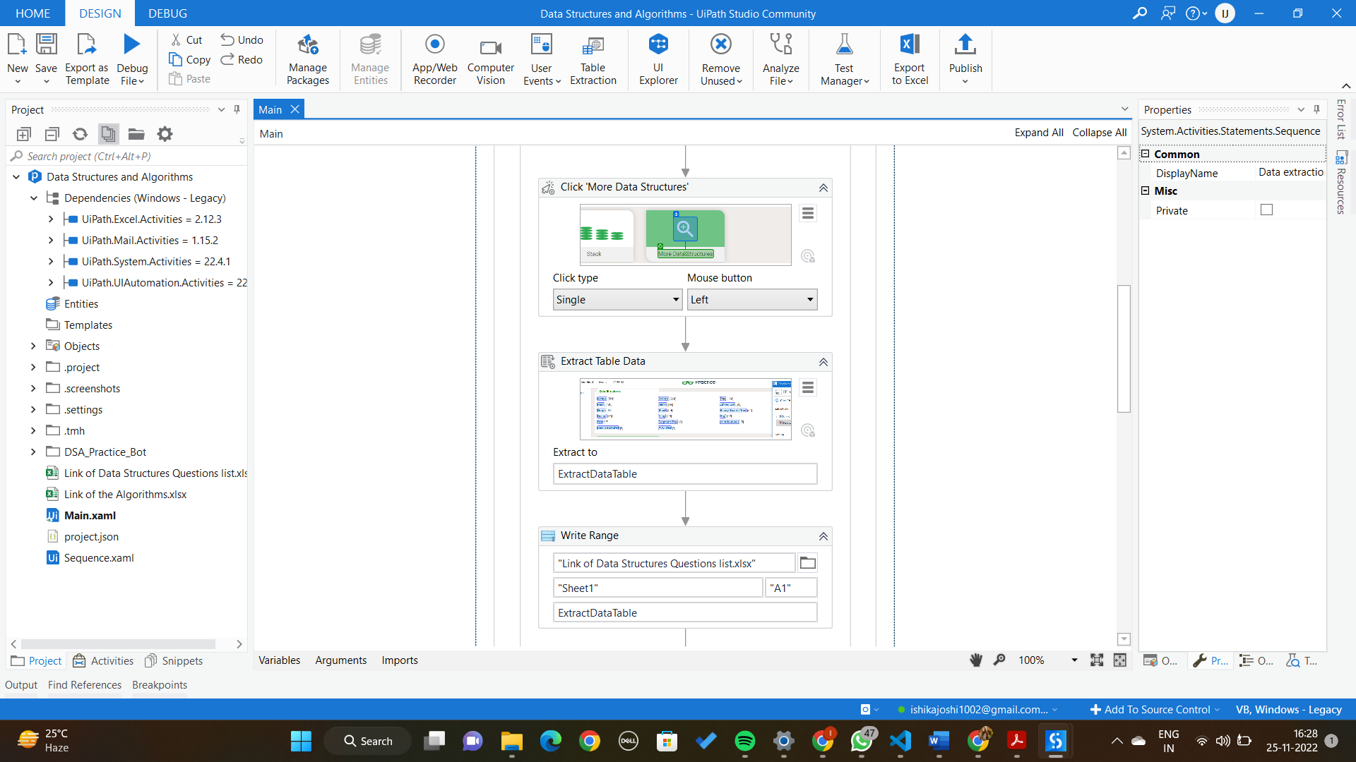

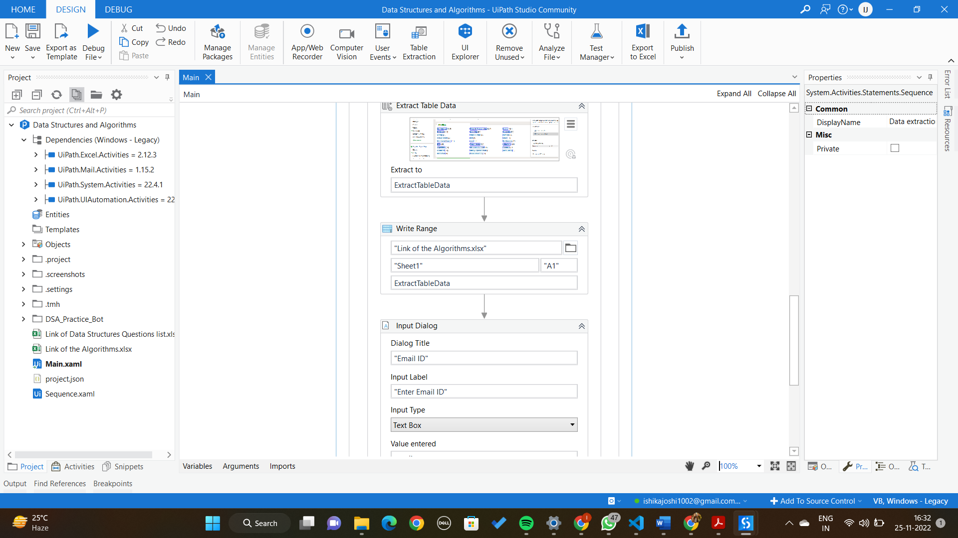

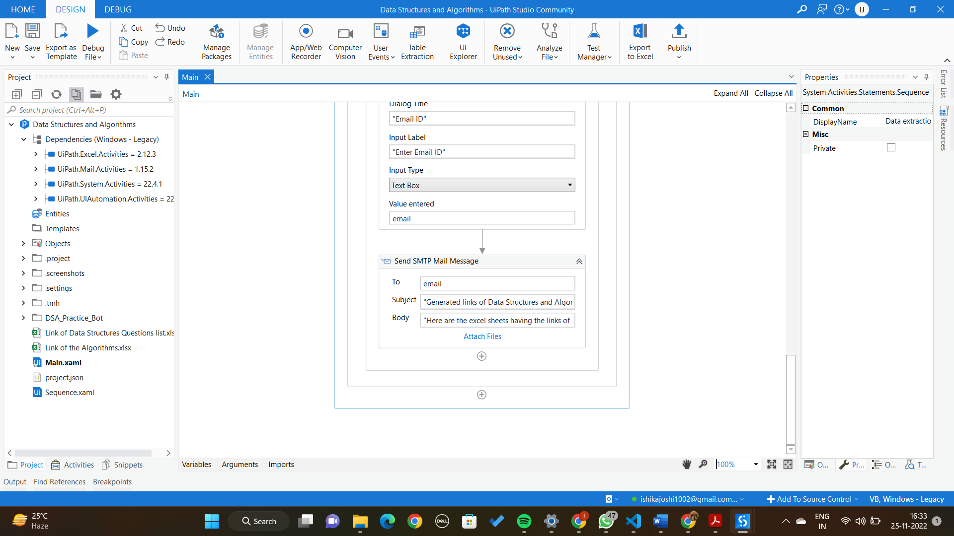

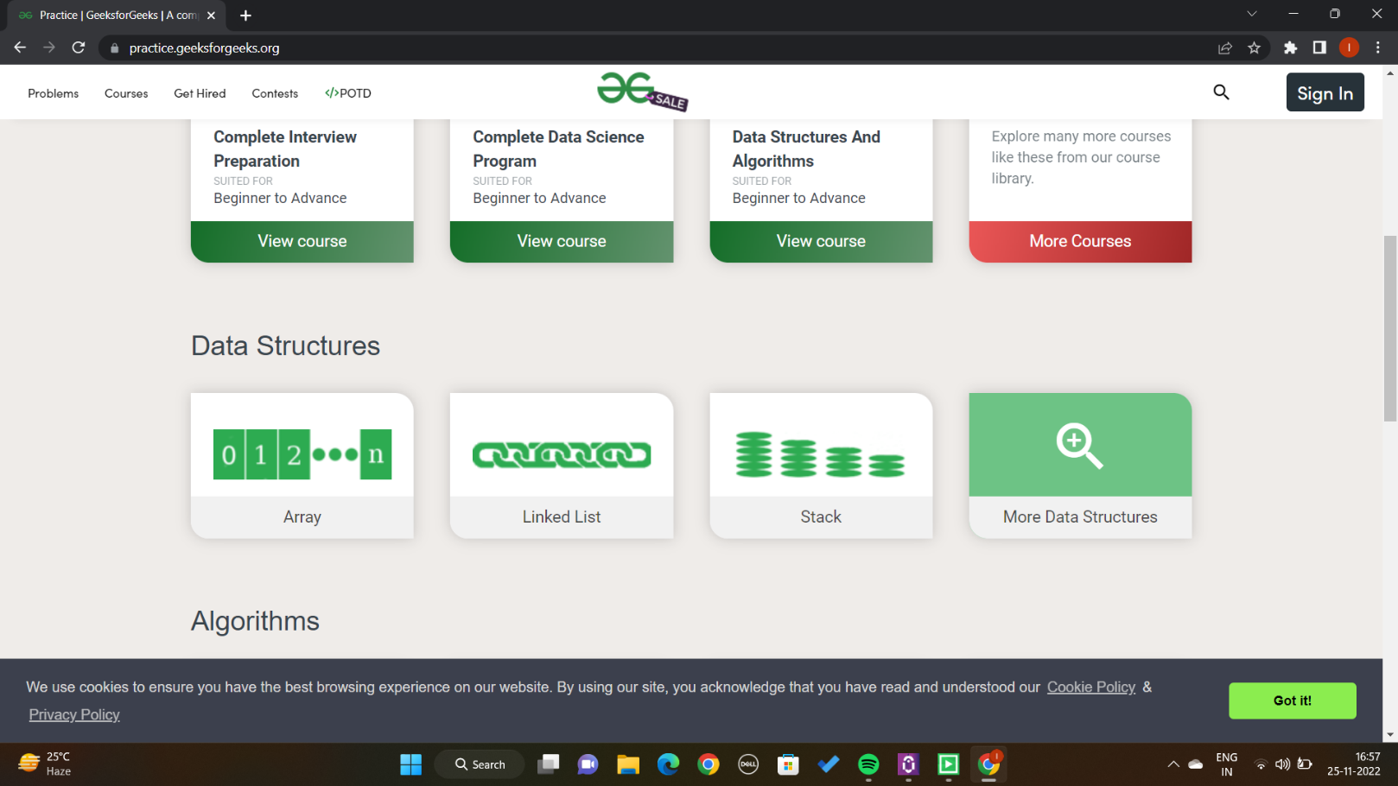

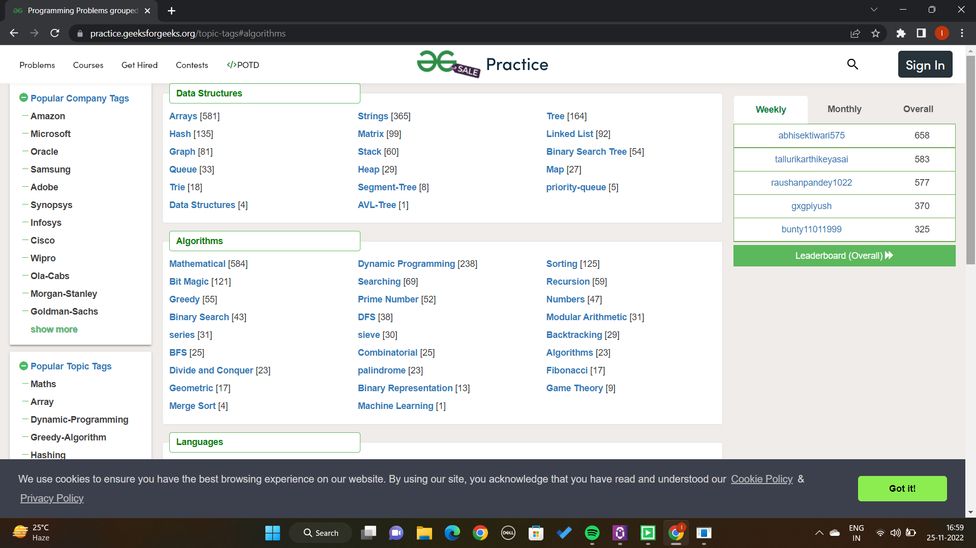

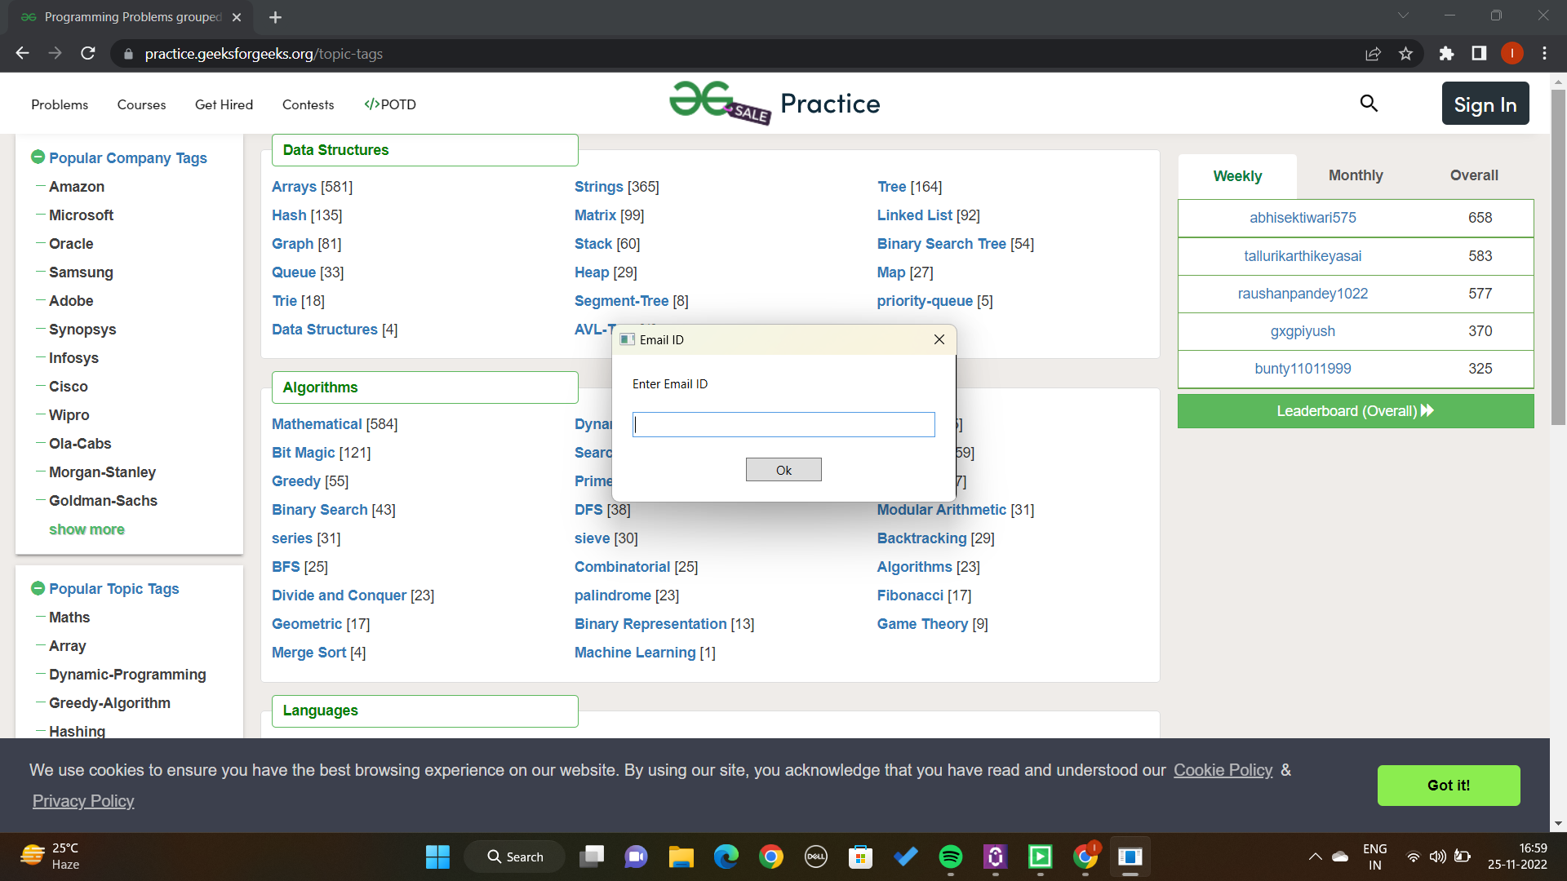

# CERTIFICATE



# Github Links

<https://github.com/ishikaj10/DSA_Practice_Bot>.

# Conclusion

# The Topic of project of Robotic Process Automation was fundamentally explained. Due to its non-invasive integration into the existing system landscape, Robotic Process Automation can be easily introduced and initial processes can be automated quickly. This makes it a good way to approach the topic of digitization in your Institute or to expand it further.

# References

[www.google.com](http://www.google.com)

[www.youtube.com](http://www.youtube.com)

<https://academy.uipath.com/>